Module 13 - Laravel Foundation Step-12 (Assignment)

**Part 1: Laravel Installation**

**Step 1** – Install artisan

**Step 2** – Install laravel installer with following command,

composer global require laravel/installer

**Step 3** – Create a new laravel application with following command,

laravel new new-project

**Step 4** – Run the installed laravel application with the following command,

php artisan serve

**Screenshot:**

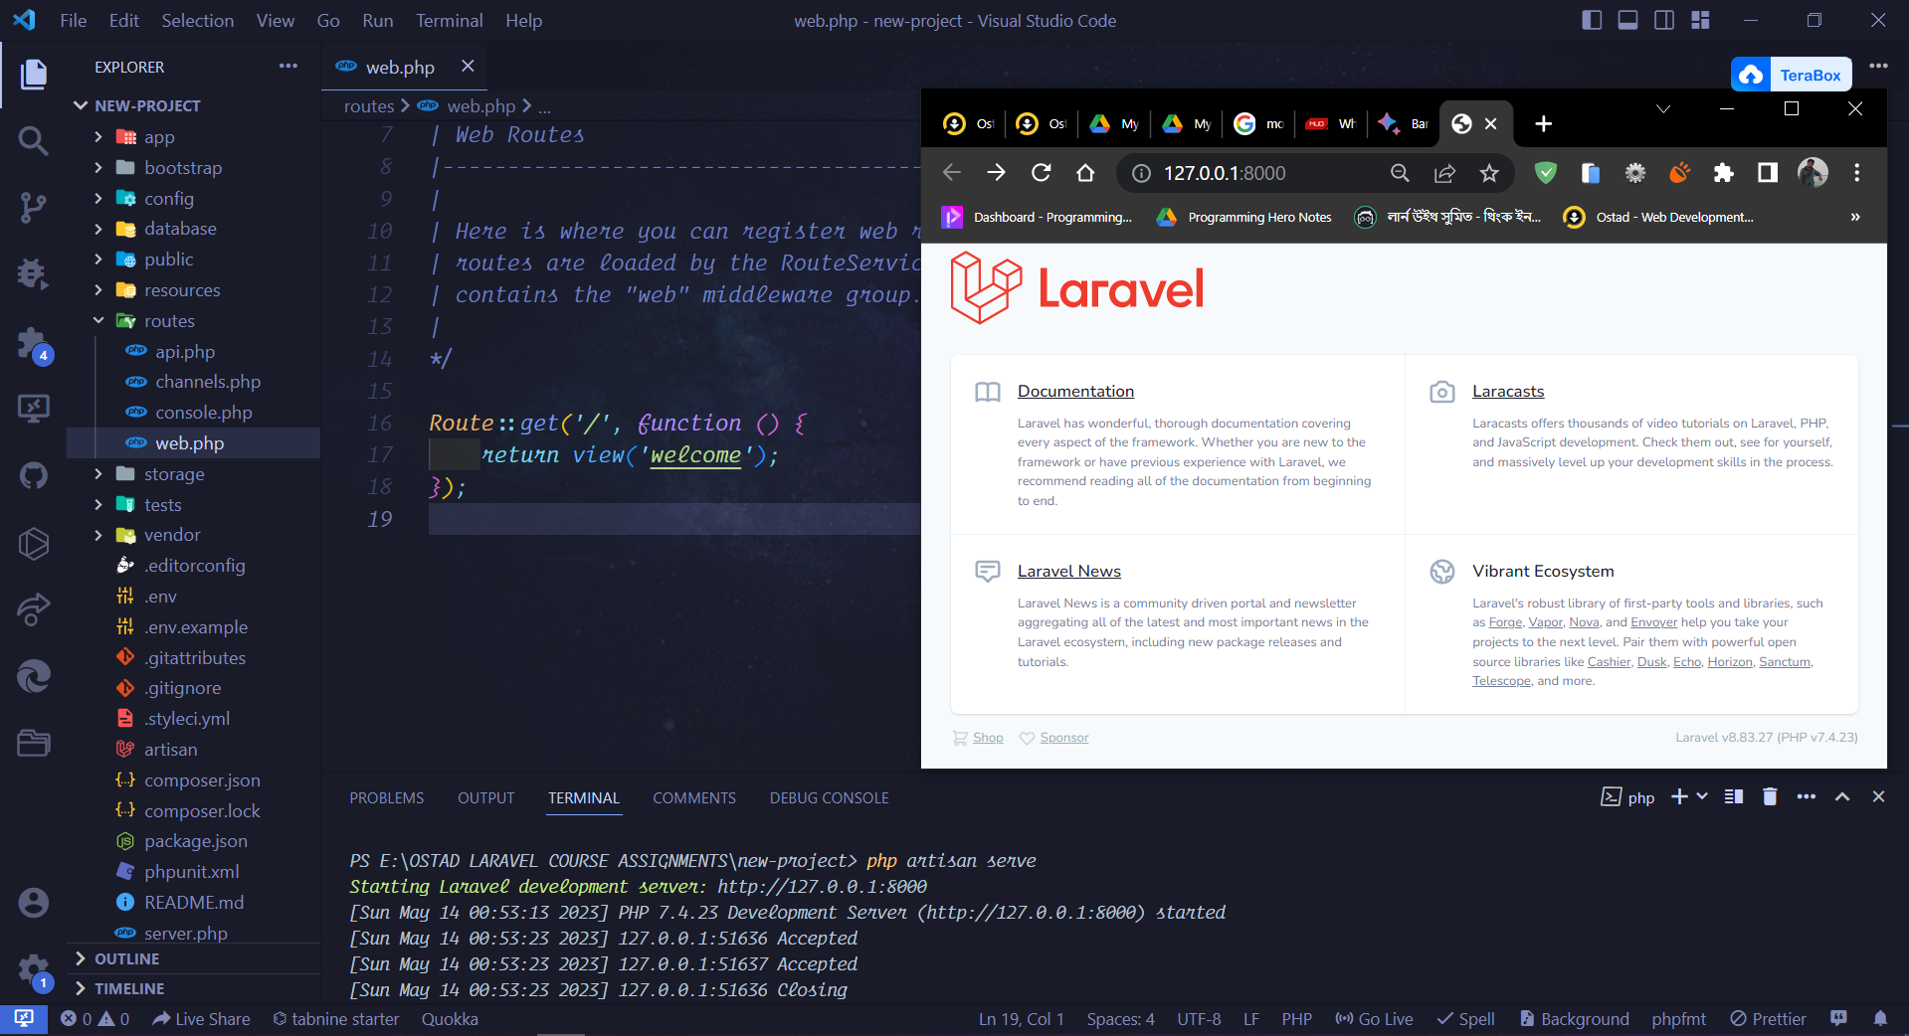

**Part 2: Laravel Folder Structure**

Here is a description of the purpose of each folder in a Laravel project:

* **app** - This folder contains the core files of your application, such as your controllers, models, and views.
* **bootstrap** - This folder contains the bootstrapping files for your application, such as the app.php file, which loads the framework and configures your application.
* **config** - This folder contains the configuration files for your application, such as the database connection settings and the mail settings.
* **database** - This folder contains the database files for your application, such as the .sql files that create your database tables.
* **public** - This folder contains the public files for your application, such as the CSS, JavaScript, and images that are served to your users.
* **resources** - This folder contains the static resources for your application, such as the Sass files, language files, and templates.
* **routes** - This folder contains the routing files for your application, which define how requests are routed to controllers.
* **storage** - This folder contains the application's storage files, such as the logs, sessions, and caches.
* **tests** - This folder contains the test files for your application, which are used to test the functionality of your application.
* **vendor** - This folder contains the Composer dependencies for your application.

**Screenshot:**

